Project Spectre - FPV Gimbal System

Alexis Holmes

*Whitacre College of Engineering*

*Texas Tech University*

Lubbock, Texas

[a.holmes@ttu.edu](mailto:a.holmes@ttu.edu)

Goethe Cruz

*Whitacre College of Engineering*

*Texas Tech University*

Lubbock, Texas

[gocruz@ttu.ed](mailto:gocruz@ttu.edu)u

Devin Shade

*Whitacre College of Engineering*

*Texas Tech University*

Lubbock, Texas

devin.shade@ttu.edu

***Abstract*—** **The paper discusses the development of a robot that can autonomously view and capture live video feed in potentially dangerous situations, removing the need for human presence. The project incorporates STEM concepts, particularly video processing and streaming via microcontroller. The captured data is sent to an intermediary laptop that transfers it to a virtual headset, allowing the user to see what the camera sees. While the project has potential use in the military, police, and national search and rescue operations, it is limited by the hardware used and other constraints such as battery life, data transmission, and range of transmission. Future developments could involve the medical industry once nanotechnology and micro-robotics become more widely accessible. The paper covers the planning, design, development, and implementation of the project in detail.**

***Keywords*—VR, head tracking, Gimbal, PCB, Virtual Environment, Raspberry Pi, Arduino Nano, Bluetooth**

I. INTRODUCTION

Virtual environments have been evolving over the last decade, and the technology’s applicatory potential expanding more than many thought possible [1]. One aspect of virtual technology is the removal of risk from a situation, by removing the person involved in the project. For example, in many emergency or high-risk situations, often times human lives are placed on the line to secure that of others. This necessitates there be brave and courageous people out there to take up the role of heroes. Another example includes search and rescue, as not only is the main aspect of finding a lost person and giving aid stressful and full of risk, but the mental strain that results may have long lasting effects, i.e., PTSD, anxiety, etc. [2]. A simple yet effective solution is presented by the project discussed in this paper; mainly the idea of a remote “virtual” environment that eliminates the need for human presence in a high-risk situation. The entire project is composed of 3 micro controllers, a camera, gyroscopic and accelerometer sensors, a virtual reality headset, and a gimbal or robotic apparatus. Much research has already been conducted on the mechanical technology used for this project, namely the camera streaming used in bomb defusal [3] and of course the gyroscopic technology for the user’s headset [4]. The paper will follow conventional IEEE topic format, with the following section being the methods used, then the results and discussion, followed by the conclusion, and finally ending with some acknowledgements.

II. Methods

A big draw of this solution is the use of a FPV, or first-person view, headset [5]. This means that the application of this project will be more ergonomic and facilitate use in stressful situations. In order to accomplish this, an Oculus Rift headset is used as the virtual machine, which receives its video feed from an intermediary laptop that communicates with a Raspberry Pi 4, Model B. A gyroscope and accelerometer sensor sends data through a pair of Arduino Nano’s in order to operate the robotic apparatus that holds the camera. Video processing will be done with OpenCV and Python. Using this combination of hardware and software, this project poses a possible solution to the problem at hand.

Fig. 1 Project Sketch

1. *Hardware*

The main component and celebrity of the assembly is the Oculus Quest II VR headset. This device is a self-contained virtual machine unit that is commercially available and mostly used for entertainment, education, gaming, and other consumer activities involving low power applications. The current design for this project incorporates a specialized and heavily shielded USB-C cable to connect the machine to a laptop. The laptop has VR capabilities and uses Virtual Desktop, an off-the-shelf solution for connecting the Oculus to a Microsoft operating system. This laptop serves as the brains of the project, linking together the other main components and letting them communicate with each other. The Raspberry Pi’s sole purpose is to process the video feed that a raspberry specific HD camera captures and send it to the VR headset. 2 Arduino Nano’s collect and use gyroscope data from an MPU6050 gyroscope/accelerometer sensor to dictate what movements a gimbal system should take to accurately mimic the users head movements. The gimbal arms and base are 3-D printed and based off of a design by D. Nedelkovski. Each of the three arms control one axis of movement, being either pitch, roll, or yaw. Power was supplied by standard 9.6 V batteries for the servo motors and the microcontrollers.

Fig. 2 VR Headset with MPU6050

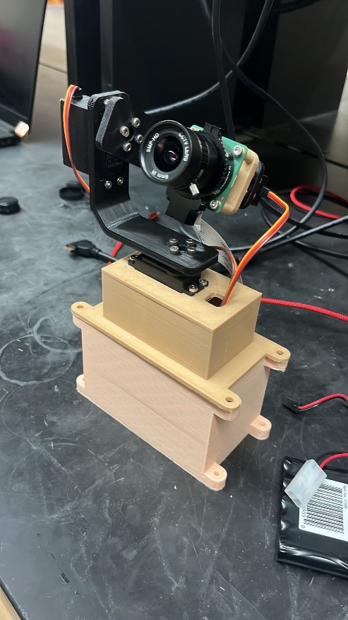

Fig. 3 Cam Mounted on Gimbal

Most of the hardware for this project was already built with the exception of the gimbal arm-assembly and a specialized PCB designed for servo motor operations and hub for the one of the Arduinos.

Fig. 4 PCB Designed by A. Holmes

1. *Software*

There are 2 main software programs to control this product. One of these programs is called RPI Webcam Interface, which allows the video feed captured by the Pi camera to be directly streamed to an IP-specific website address on the same network as the Raspberry device. This is an application that can be found online and used by anyone.

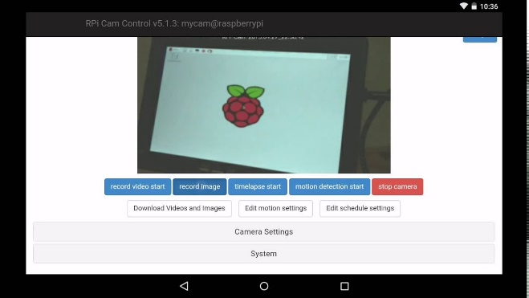

Fig. 5 RPi Webcam Interface

The next main program is written for the Arduino Nano’s to capture and send gyroscope and accelerometer data. This program is composed of 2 main scripts, a “send” script and a “receive” script, which do as the names imply. One very important aspect of this project is the use of Virtual Desktop, an online Steam application that allows Oculus to act as a Windows OS emulator. This project needs this application solely for the sticky screen feature, which allows the window within the virtual environment to be “pinned” to the screen. Without this feature, the screen would not follow the users head movement, rendering the entire premise of this project moot.

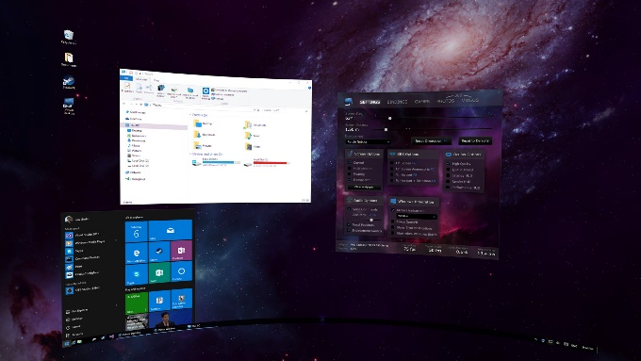

Fig. 6 Virtual Desktop

III. Results & Discussion

The results from testing of this project served as proof of concept. For the demonstration of this project, the team was able to properly operate the gimbal apparatus with only head movements from the user. The camera feed properly streamed to the website with the program used, and the motors moved in accordance with the data received from the MPU6050. However, a few improvements are needed if this is to become a viable product for service in the industries presented as examples earlier in this paper. This includes increasing the accuracy and range of communication between the microcontrollers and the virtual reality headset, as they were lackluster and insufficient for real-world application. The length of the heavily shielded cable created an unexpected constraint to the project as a whole as well. A protected network is also another possible constraint due to the nature of how the live feed from the camera is relayed to the website. As mentioned before, the website has a domain with an IP address specific to the network that all the devices operate on. This means that although a user needs the IP address of the network in order to access the feed, anyone who acquires this address can see the feed. This is an obvious security concern for operations involving police or medical information and will need to be considered for these types of applications. Furthermore, better hardware for the gyroscope and accelerometer must be used, in conjunction with more sophisticated materials for the gimbal system. One possibility is the replacement of 3-D printed components with metal machined components. A better camera and higher processing power would also greatly improve the frame rate as seen by the user in the VR headset. A specialized program and VR machine may also be considered for further improvements, as using a commercially available and consumer focused machine might be lacking features and specifications for previously mentioned industries.

IV. Conclusion

The project is a remote-controlled gimbal system that is designed to be operated using only head movements from the user. The system is composed of several components, including a virtual reality headset, a microcontroller, and a camera mounted on a 3-axis gimbal. The gimbal is connected to the Arduino Nano BLE microcontroller, which is responsible for receiving data from a gyroscope and accelerometer module, known as MPU6050, and then controlling the motors of the gimbal accordingly. During the testing phase, the team was able to demonstrate the system's functionality by controlling the gimbal with head movements and live-streaming the camera feed to a website. However, several limitations were identified that need to be addressed before the system can be used in real-world applications. One of these limitations is improving the accuracy and range of communication between the microcontrollers and the virtual reality headset. The range of communication between the components was insufficient for real-world applications, and accuracy was lacking. This issue could potentially be addressed by using a different communication protocol or improving the hardware used for communication. Another constraint that the team encountered was the length of the heavily shielded cable that connects the camera to the microcontroller. This cable posed an unexpected challenge and needed to be addressed to ensure the proper operation of the system. The elimination of this cable would be beneficial, as it would allow for a truly remote experience and improve the system's overall performance. Additionally, the team identified security concerns with the live feed from the camera that was relayed to the website. The website has a domain with an IP address specific to the network that all the devices operate on, which means that anyone who acquires the address can see the feed. This is an obvious security concern for operations involving sensitive information, such as medical or police-related applications. The team proposed the use of a protected network to address this concern.

To improve the accuracy and performance of the system, a proposed use of better hardware for the gyroscope and accelerometer, in conjunction with more sophisticated materials for the gimbal system. One possibility is the replacement of 3-D printed components with metal machined components. Additionally, better cameras and higher processing power can greatly improve the frame rate as seen by the user in the VR headset. A specialized program and VR machine may also be considered for further improvements, as using a commercially available and consumer-focused machine might not be suitable for previously mentioned industries. In conclusion, the remote-controlled gimbal system demonstrates proof of concept for operating the gimbal with only head movements from the user and properly streaming the camera feed to the website. However, to make it a viable product for service in industries such as police, military, search and rescue, or medical, significant improvements are needed. These include increasing accuracy and range of communication, addressing security concerns with live feed, using better hardware and materials for the gimbal system, and upgrading the camera and processing power. A specialized program and VR machine may also be necessary for further improvements to make it suitable for these industries.

Overall, the project shows promise, but there is still work to be done to make it a successful product in real-world applications.

V. Acknowledgments

I would like to take this section to thank a few people who assisted this project over the course of the semester. Firstly, my lab partners, Devin Shade, and Alexis Holmes for each taking their fair share of responsibilities on. Secondly, Derek A. Johnston, our mentor and sponsor for this project, initially proposed an FPV based project. His guidance and expertise were invaluable in the design and implementation of this project. Thirdly, Texas Tech University, for use of its laboratories, electronic testing components and other facilities that aided in the testing of this project. Finally, a special thanks to Dr. Hemmert for a wonderful and fun semester!

References

1. F. Pallavicini, L. Argenton, N. Toniazzi, L. Aceti, and F. Mantovani, “Virtual reality applications for stress management training in the military,” *Latest TOC RSS*, 01-Dec-2016. [Online]. Available: https://www.ingentaconnect.com/content/asma/amhp/2016/00000087/00000012/art00009. [Accessed: 25-Feb-2023].
2. P. G. Velden, P. van Loon, C. C. Benight, T. Eckhardt, e, AbstractSearch and rescue workers play an important role in rescuing trapped disaster victims. However, C. B. Yeh, Z. Wang, P. G. van der Velden, M. Joensuu, Y. J. Guo, R. Gabriel, T. Ehring, C. M. Chang, N. K. Aaronson, D. A. Alexander, J. Alvarez, W. A. Arrindell, M. Ben-Ezra, C. C. Benight, R. V. Bijl, A. Blokstra, R. M. Brackbill, J. Brown, L. R. Derogatis, W. P. Dunlap, and G. G. D. N. (H. A. Netherlands), “Mental health problems among search and rescue workers deployed in the haïti earthquake 2010: A pre–post comparison,” *Psychiatry Research*, 30-Jun-2012. [Online]. Available: https://www.sciencedirect.com/science/article/abs/pii/S0165178112000996. [Accessed: 25-Feb-2023].
3. T. Prenzler, “Towards prevention: A situational study of police deaths on duty in Queensland,” *Taylor & Francis*, 03-Dec-2018. [Online]. Available: https://www.tandfonline.com/doi/abs/10.1080/10345329.2006.12036382?journalCode=rcic20. [Accessed: 24-Feb-2023].
4. A. A. Chowdhury, M. A. Hamid and M. N. A. S. Ivan, "Implementation of Cost Effective Bomb Defusing Robot with Live Streaming Dual Camera Interface," *2021 2nd International Conference on Robotics, Electrical and Signal Processing Techniques (ICREST)*, DHAKA, Bangladesh, 2021, pp. 439-444, doi: 10.1109/ICREST51555.2021.9331203.
5. L. R. Rochlen, R. Levine, and A. R. Tait, “First-person point-of-view-augmented reality for Central line insertion training: A usability and Feasibility Study,” *Simulation in healthcare : journal of the Society for Simulation in Healthcare*, 01-Feb-2017. [Online]. Available: https://www.ncbi.nlm.nih.gov/pmc/articles/PMC5285452/. [Accessed: 26-Feb-2023].